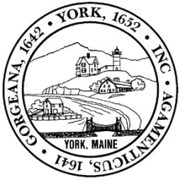
AGENDA
York GEROD Subcommittee
Thursday, July 20, 2023
8:00 AM
York Public Library

1. Call to Order; Determination of Quorum;
2. Discussion-
- Meeting schedule (Public Kick-Off, Codeapalooza)
- Meeting schedule (Regular)
- Marketing (Groups to notify/Materials)
3. Minutes
4. Other Business
5. Adjourn

